Casting wall thickness for castability and internal pressure

Index
1. Purpose & Scope 3
2. Definitions 3
3. Thickness calculation 4
3.1. General procedure: description 5
3.2. Thickness calculated by formula (ASME BPVC Section III). 6
4. References 7

PURPOSE & SCOPE
This procedure establishes the requirements for determining the casting wall thickness of radially split, single-volute, and double-volute single-suction pumps, ensuring both castability and compliance with internal pressure design codes.
This procedure applies to Nova Milanese and La Spezia plants.

DEFINITIONS
A Scroll diameter
C.F. Casting factor
p Internal design pressure [MPa or psi]
S Allowable stress [MPa or psi]
Sy Yield stress at operating temperature [MPa or psi]
Su Ultimate stress at operating temperature [MPa or psi]
t_{o} Minimum corrosion allowance [mm or in]
t₁ Casting wall thickness for castability [mm or in]
t₂ Minimum allowable thickness for ASME BPVC Section III, ND3440
t_{opt} Minimum allowable thickness [mm or in]

THICKNESS CALCULATION
This procedure is based on two main requirements:
- Castability limits.
- Minimum thickness calculated by formula.

Pump type A | Pump type B
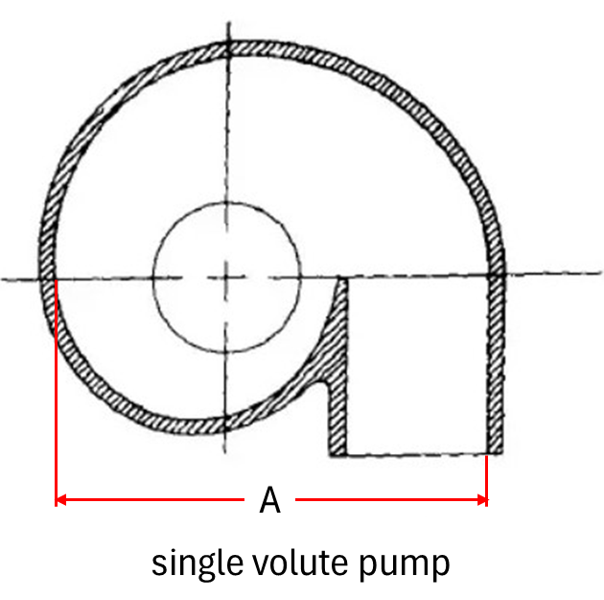 | 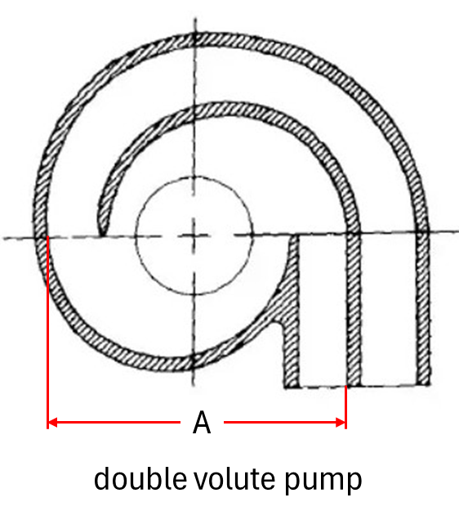
Figure 1: Pump types.

Figure 1 illustrates the geometries considered within this procedure, defining the scroll diameter for both single and double-volute pumps.
The allowable thickness t_{opt} is determined as the greater value betweent₁ and t₂.
Mod.546 can be used for all the required calculations.

General procedure: description
Figure 2 presents the minimum casting wall thickness requirements based on manufacturer experience, thereby providing the definition of the minimum wall thickness necessary from a castability perspective t₁.

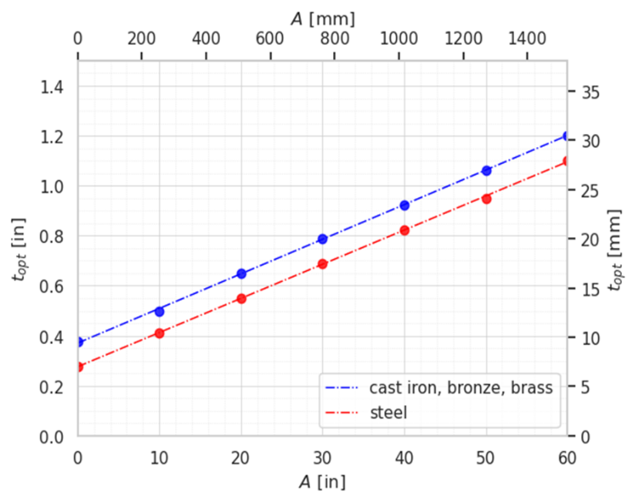 | A [in] t_{cast iron} [in] t_{steel} [in]  0 0.3750 0.2750  10 0.5000 0.4125  20 0.6500 0.5500  30 0.7875 0.6875  40 0.9250 0.8250  50 1.0625 0.9500  60 1.2000 1.1000
Figure 2: Castability limits.

Thickness calculated by formula (ASME BPVC Section III).
The minimum required wall thickness t₂ for internal pressure shall be calculated in accordance with the ASME Boiler and Pressure Vessel Code (BPVC), Section III, ND3440.
Figure 3 summarizes the formulas of ASME BPVC Section III for calculating t₂.
Pump type A | Pump type B
$$S=C.F.×\min\left({Su}/{3.5};{Sy}/{1.5}\right)$$
$$t_{2}=max\left(\tilde{t},\frac{pA}{S}\right)+t_{0}$$ | $$t_{2}=max\left(\tilde{t},\frac{pA}{2S}\right)+t_{0}$$
$C.F.$ casting factor
$S$ allowable stress including casting factor
$Sy$ yield stress at operating temperature
$Su$ ultimate stress at operating temperature
$t_{0}$ minimum corrosion allowance
$t_{2}$ minimum allowable thickness for ASME BPVC Section III (not less than $\tilde{t}$)
$\tilde{t}$ minimum thickness (6 mm or 0.25 in)
Figure 3: Thickness formulas.

REFERENCES
ASME Boiler Pressure Vessel Code, Section III, ND3440 Design of specific pump types
Mod.546 – Casting wall thickness for castability and internal pressure

Based on manufacturer experience.
Based on ASME BPVC Section III, ND3440 Design of specific pump types.
The table in S.I. unit is: A [mm] t_{cast iron} [mm] t_{steel} [mm] 0.00 9.53 6.99 254.00 12.70 10.48 508.00 16.51 13.97 762.00 20.00 17.46 1016.00 23.50 20.96 1270.00 26.99 24.13 1524.00 30.48 27.94
The casting factor is obtainable from: Examination Casting Factor C.F. Visual 0.8 Magnetic particle 0.85 Penetrant liquid 0.85 Radiography 1 Ultrasonic 1 Magnetic particle/penetrant liquid + ultrasonic/radiography 1

